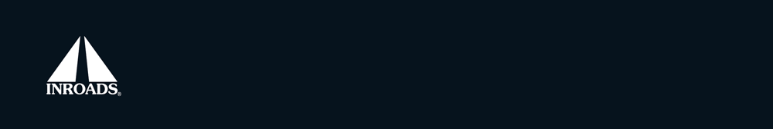

2016 INROADS
Media Consent Form

I hereby grant, authorize and give full consent to INROADS Inc., its agents, successors and assigns (“INROADS”), to copyright, publish, display, and reproduce any photographs and videos made by INROADS during the 2016 Learning Summit, in which I appear.

I also agree INROADS may use, or cause to be used, these photographs and videos in perpetuity for the sole purpose of advertising, promoting and marketing INROADS and its goods and services in any and all media now known and hereafter developed, including without limitation printed advertising, promotional and marketing materials and web sites. I agree that the photographs and videos taken are the property of INROADS, and I waive any right to review or inspection. I have read and understand this consent.

Print Name:

Signature: Date:

